Data agent for Noma’s Retail-Sale



Description
Data Agent to analyse Retail-Sales-Data
--This Agent is mainly created for the Data analyst and the company to understand the insight of the Business
--Agent needs to analyse the table given
--Agent needs to be able to Point the CEO and the data analyst on the right direction
--Agent needs to point out the minimum, maximum and average the retail has generated in the period given on this table
--Agent must also be able to calculate the total revenue the company has made during the period
--Agent also needs to be able to provide information on the product, customer_id, product _id, total amount, total revenue etc.,
--Agent will help the company understands where business is growing or lacking
--Agent will help with buying patterns and how can the company improve

Introduction
Retail sales Data agent is created to learn and analyse the data on the retail-sale table.
This is to enable the data analyst and the company to gain more insights on the company and their customer behaviour, how the sales and revenue moving up or down
What is the impact when that happens,
What to do in the future and how well or bad did the company perform.

Objectives
* To reduce manual reporting process and improve operational efficiency
* To improve future plans and sales of the company
* To avoid the mistakes or loss that the company has incurred in the previous period.
* To help the CEO and the management make informed business decisions using the real time data.

Q.1
what tables are provided on the retail sale table
Thinking complete
Retail Sales Table Structure
A.1 There is one table available: retail.sales.1776799010339_retail_sales_dataset
This table contains 9 columns tracking retail transaction data:
Transaction Details:
- Transaction ID - Unique identifier for each transaction
- Date - Transaction date (format: YYYY-MM-DD)
Customer Information:
- Customer ID - Unique customer identifier (e.g., CUST001, CUST002)
- Gender - Customer gender (Male/Female)
- Age - Customer age in years
Product Information:
- Product Category - Category of product purchased (Beauty, Clothing, Electronics)
- Quantity - Number of units purchased
- Price per Unit - Price per individual unit
- Total Amount - Total transaction value (Quantity × Price per Unit)
The data contains transactions from 2023 with various product categories and customer demographics.

ScreenShot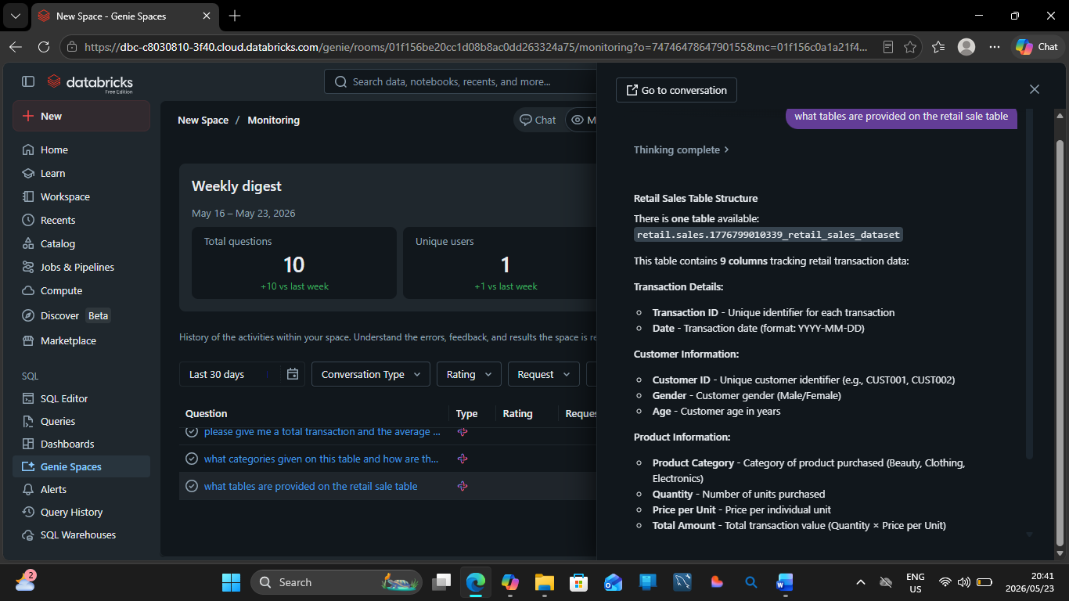

Q.1 Test Screenshot
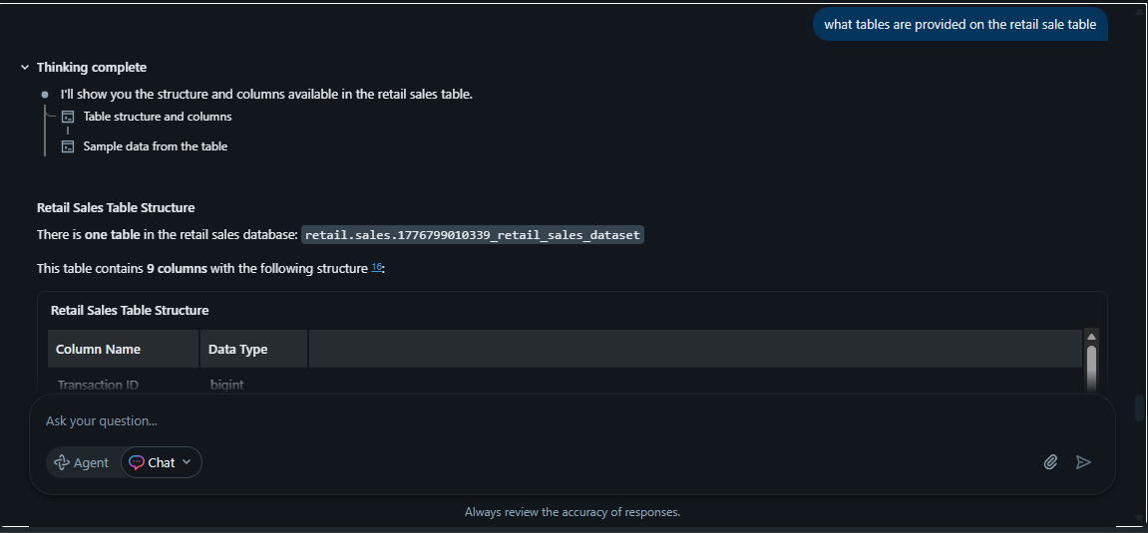
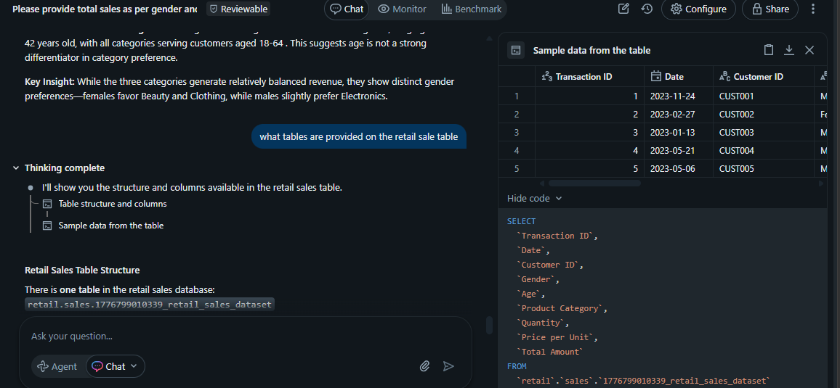

Q.2
what categories given on this table and how are they connected
Thinking complete
Categories in the Retail Sales Dataset
A.2
This table contains three main product categories: Electronics, Clothing, and Beauty, along with customer demographic categories (Gender and Age).
Product Category | Transactions | Customers | Total Revenue | Avg Customer Age | Total Quantity
Electronics | 342 | 342 | $156,905 | 41.7 | 849
Clothing | 351 | 351 | $155,580 | 41.9 | 894
Beauty | 307 | 307 | $143,515 | 40.4 | 771
Screen Shoot Q.2
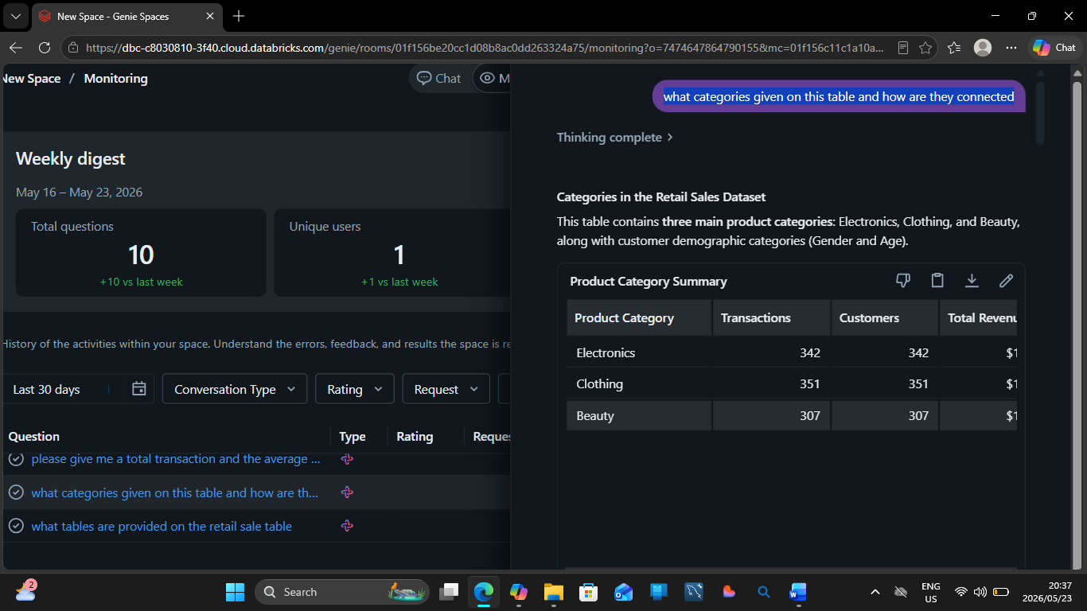
Test Screen Shoot Q.2



Q.3
please give me a total transaction and the average amount given by this table
Thinking complete
A.3
The table contains 1,000 total transactions with an average transaction amount of $456.
The total revenue across all transactions is $456,000, with individual transactions ranging from $25 (minimum) to $2,000 (maximum).

Screenshot Q.3

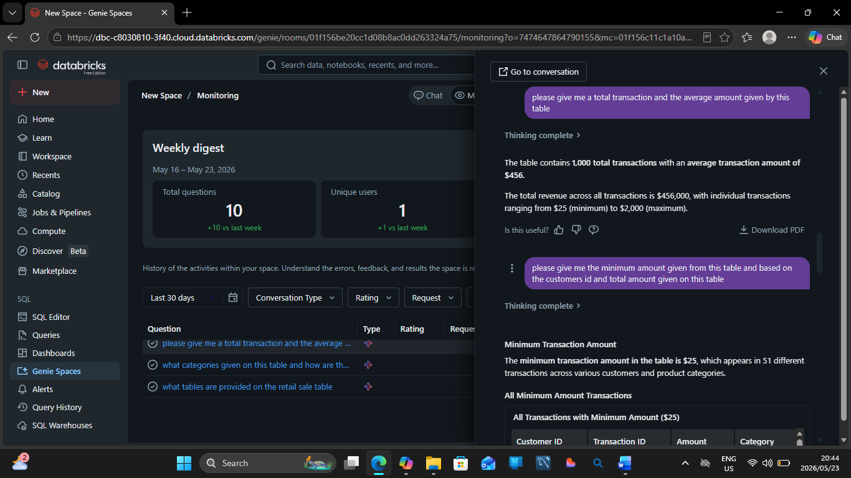

Test screenshot Q.3
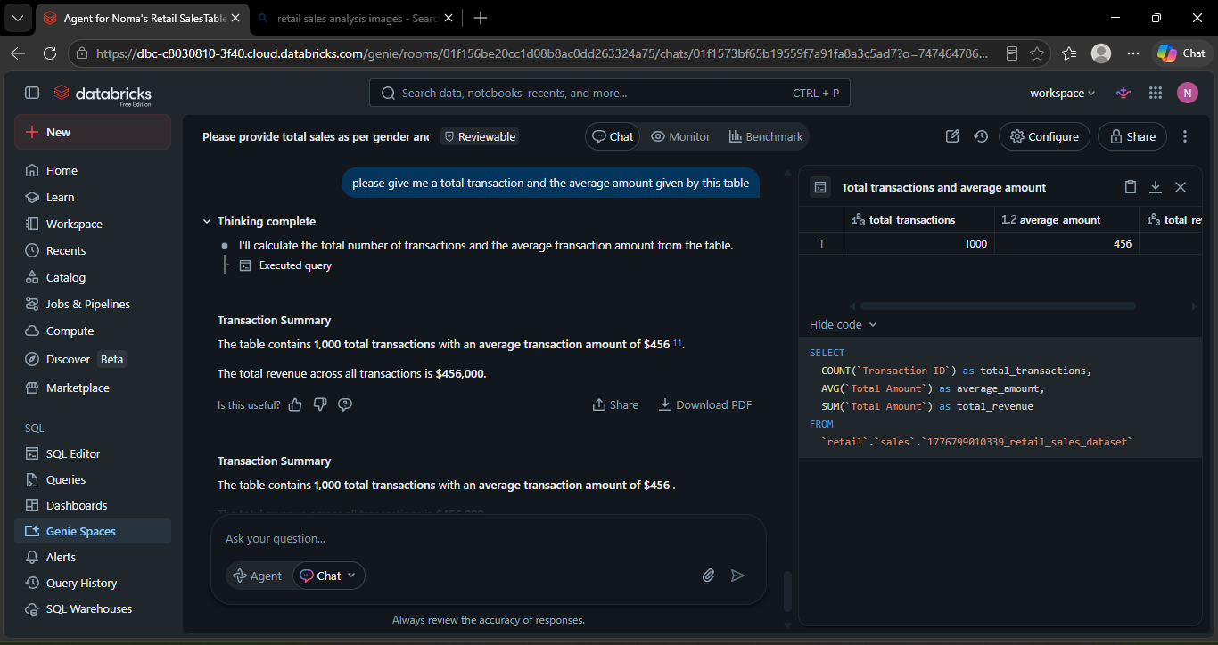

Q.4

please give me the minimum amount given from this table and based on the customers id and total amount given on this table
Thinking complete
Minimum Transaction Amount
A.4The minimum transaction amount in the table is $25, which appears in 51 different transactions across various customers and product categories.
All Minimum Amount Transactions
Customer ID | Transaction ID | Amount | Category | Date
CUST044 | 44 | $25 | Clothing | 2023-02-19
CUST103 | 103 | $25 | Clothing | 2023-01-17
CUST185 | 185 | $25 | Clothing | 2023-02-27
CUST191 | 191 | $25 | Beauty | 2023-10-18
CUST201 | 201 | $25 | Electronics | 2023-10-09
CUST204 | 204 | $25 | Beauty | 2023-09-28
CUST205 | 205 | $25 | Clothing | 2023-11-07
CUST206 | 206 | $25 | Clothing | 2023-08-05
CUST223 | 223 | $25 | Clothing | 2023-02-02
CUST230 | 230 | $25 | Beauty | 2023-04-23
CUST232 | 232 | $25 | Beauty | 2023-02-06
CUST236 | 236 | $25 | Clothing | 2023-04-28
CUST242 | 242 | $25 | Clothing | 2023-05-02
CUST285 | 285 | $25 | Electronics | 2023-08-15
CUST309 | 309 | $25 | Beauty | 2023-12-23
CUST310 | 310 | $25 | Beauty | 2023-10-12
CUST318 | 318 | $25 | Clothing | 2023-10-24
CUST347 | 347 | $25 | Electronics | 2023-08-03
CUST362 | 362 | $25 | Clothing | 2023-11-27
CUST363 | 363 | $25 | Beauty | 2023-06-03
CUST371 | 371 | $25 | Beauty | 2023-02-21
CUST379 | 379 | $25 | Clothing | 2023-02-05
CUST388 | 388 | $25 | Electronics | 2023-11-10
CUST397 | 397 | $25 | Beauty | 2023-03-10
CUST423 | 423 | $25 | Clothing | 2023-03-08

- 1
- 2
- 3

These $25 transactions are distributed across all three product categories (Clothing, Beauty, and Electronics) and occurred throughout 2023 with different customers.
Customers with Lowest Total Spending
When looking at customers by their total spending, there are multiple customers who made only one transaction of $25, making them the lowest-spending customers in the dataset.
Customer ID | Transactions | Total Spent | Avg Transaction | Min | Max
CUST205 | 1 | $25 | $25 | $25 | $25
CUST204 | 1 | $25 | $25 | $25 | $25
CUST185 | 1 | $25 | $25 | $25 | $25
CUST223 | 1 | $25 | $25 | $25 | $25
CUST201 | 1 | $25 | $25 | $25 | $25
CUST191 | 1 | $25 | $25 | $25 | $25
CUST103 | 1 | $25 | $25 | $25 | $25
CUST044 | 1 | $25 | $25 | $25 | $25
CUST206 | 1 | $25 | $25 | $25 | $25
CUST230 | 1 | $25 | $25 | $25 | $25
All of these customers made exactly one purchase of $25, representing the minimum possible customer lifetime value in this dataset.
Screen Shot Q.4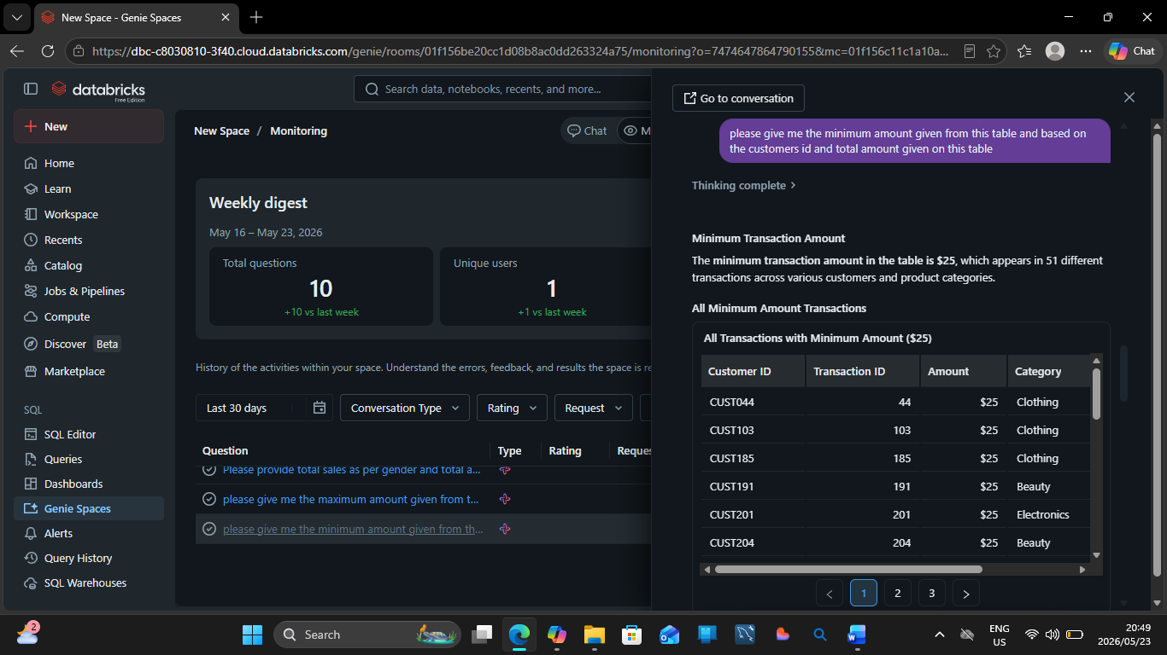
Test screenshot Q.4


Q.5
Q.5
please give me the maximum amount given from this table and based on the customers id and total amount given on this table
Thinking complete
A.5
- Maximum transaction amount details
- Customers with highest total spending
- Maximum transaction amount details simplified
Maximum Transaction Amount
The maximum transaction amount in the table is $2,000, which appears in 49 different transactions across various customers and product categories.
All Maximum Amount Transactions
Customer ID | Transaction ID | Amount | Category | Date
CUST015 | 15 | $2,000 | Electronics | 2023-01-16
CUST065 | 65 | $2,000 | Electronics | 2023-12-05
CUST072 | 72 | $2,000 | Electronics | 2023-05-23
CUST074 | 74 | $2,000 | Beauty | 2023-11-22
CUST089 | 89 | $2,000 | Electronics | 2023-10-01
CUST093 | 93 | $2,000 | Beauty | 2023-07-14
CUST109 | 109 | $2,000 | Electronics | 2023-10-18
CUST118 | 118 | $2,000 | Electronics | 2023-05-16
CUST124 | 124 | $2,000 | Clothing | 2023-10-27
CUST139 | 139 | $2,000 | Beauty | 2023-12-15
CUST152 | 152 | $2,000 | Electronics | 2023-02-28
CUST155 | 155 | $2,000 | Electronics | 2023-05-17
CUST157 | 157 | $2,000 | Electronics | 2023-06-24
CUST166 | 166 | $2,000 | Clothing | 2023-04-02
CUST253 | 253 | $2,000 | Clothing | 2023-08-31
CUST257 | 257 | $2,000 | Beauty | 2023-02-19
CUST269 | 269 | $2,000 | Clothing | 2023-02-01
CUST281 | 281 | $2,000 | Beauty | 2023-05-23
CUST342 | 342 | $2,000 | Clothing | 2023-10-24
CUST412 | 412 | $2,000 | Electronics | 2023-09-16
CUST416 | 416 | $2,000 | Electronics | 2023-02-17
CUST420 | 420 | $2,000 | Clothing | 2023-01-23
CUST447 | 447 | $2,000 | Beauty | 2023-07-06
CUST476 | 476 | $2,000 | Clothing | 2023-08-29
CUST480 | 480 | $2,000 | Beauty | 2023-06-29

- 1
- 2

These $2,000 transactions are distributed across all three product categories throughout 2023:
- Electronics: 21 transactions
- Clothing: 17 transactions
- Beauty: 11 transactions
Customers with Highest Total Spending
When looking at customers by their total spending, all of the top customers made exactly one transaction of $2,000, making them tied for the highest-spending customers in the dataset.
Customer ID | Transactions | Total Spent | Avg Transaction | Min | Max
CUST109 | 1 | $2,000 | $2,000 | $2,000 | $2,000
CUST089 | 1 | $2,000 | $2,000 | $2,000 | $2,000
CUST074 | 1 | $2,000 | $2,000 | $2,000 | $2,000
CUST124 | 1 | $2,000 | $2,000 | $2,000 | $2,000
CUST072 | 1 | $2,000 | $2,000 | $2,000 | $2,000
CUST093 | 1 | $2,000 | $2,000 | $2,000 | $2,000
CUST015 | 1 | $2,000 | $2,000 | $2,000 | $2,000
CUST065 | 1 | $2,000 | $2,000 | $2,000 | $2,000
CUST118 | 1 | $2,000 | $2,000 | $2,000 | $2,000
CUST139 | 1 | $2,000 | $2,000 | $2,000 | $2,000
Each of these customers made a single high-value purchase of $2,000, representing the maximum possible customer lifetime value in this dataset. Since each customer appears to have made only one transaction, the highest spenders are simply those who made the maximum-value transaction.

Q.5 Screen Shoot
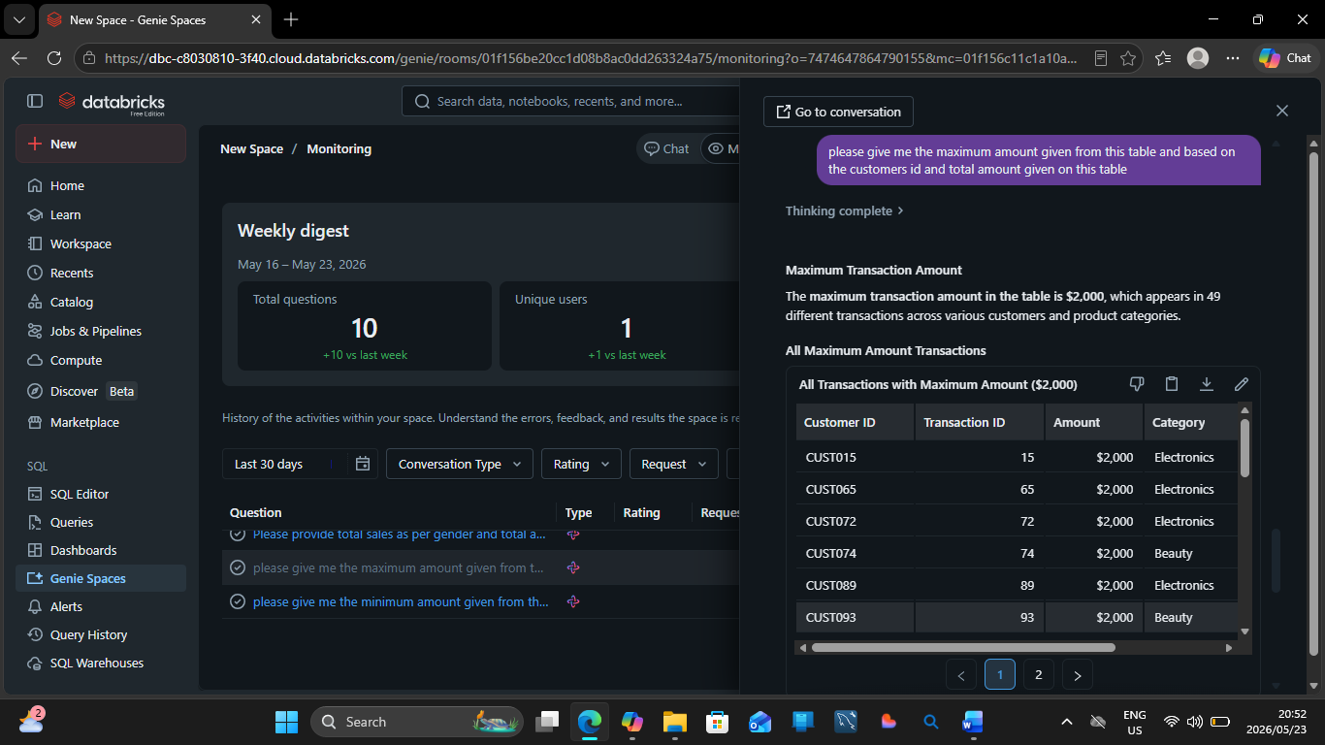

Test Screenshot Q.5
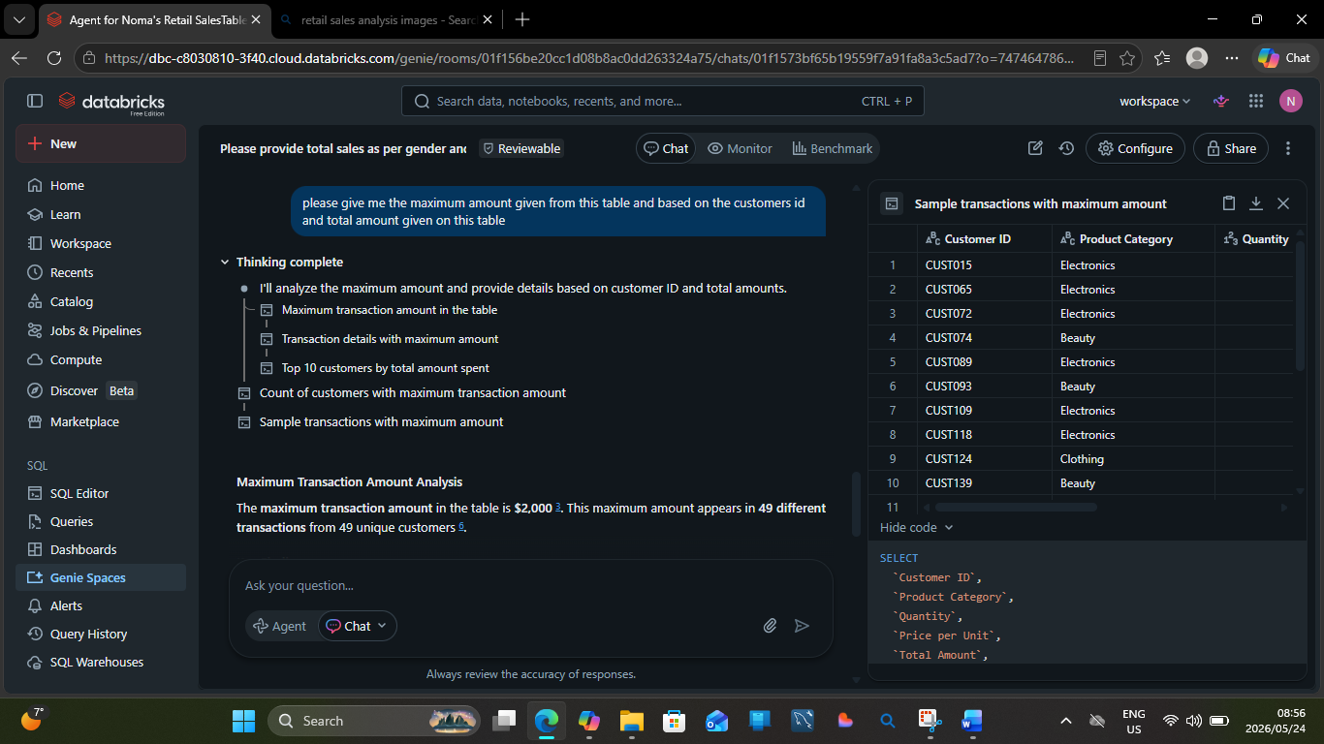

Q.6
Please provide total sales as per gender as female,male and total amount spent by each gender
Thinking complete
A.6
Sales Analysis by Gender
Female customers lead in both total sales transactions and spending, accounting for 510 sales and $232,840 in total spending, while male customers made 490 sales totaling $223,160.
Gender | Total Sales | Total Amount Spent
Female | 510 | $232,840
Male | 490 | $223,160

Screenshot
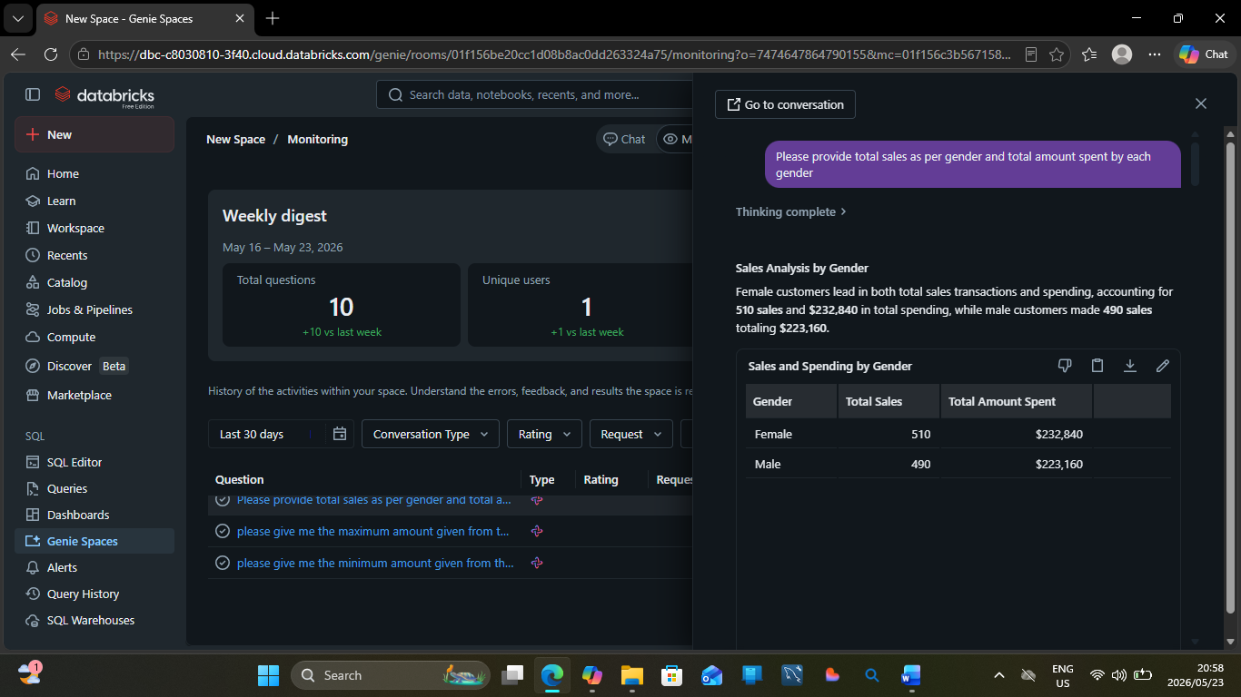

Q.6 Test Screenshot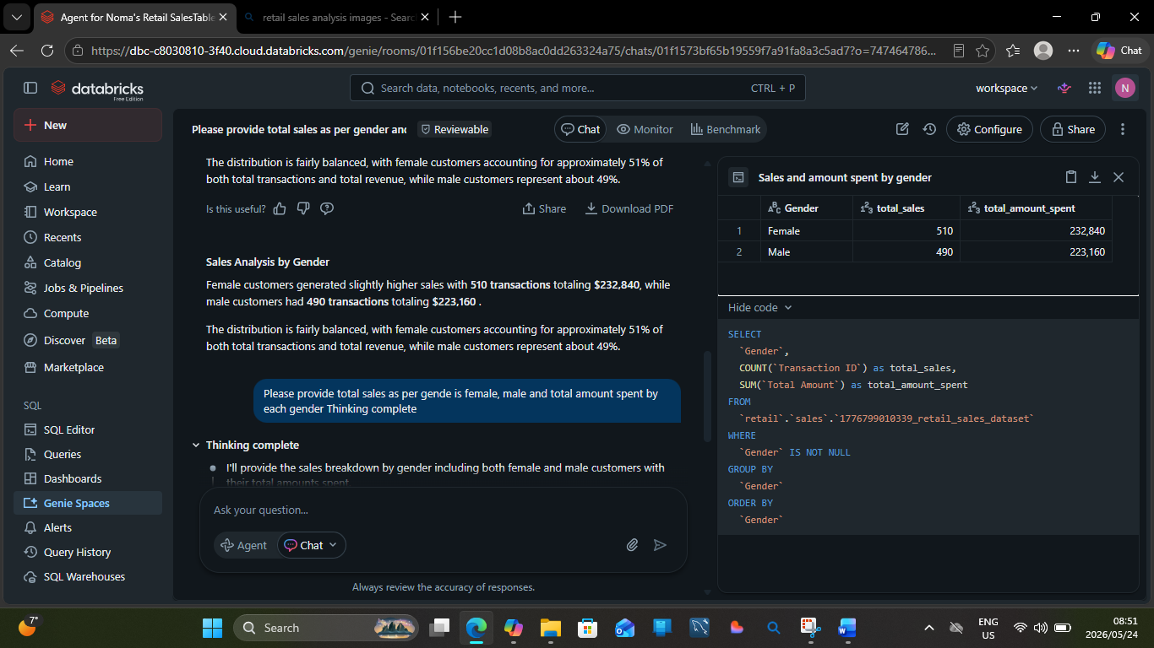

Q.7
Please provide total sales as per gender and total amount spent by each gender
Thinking complete
A.7
Sales Analysis by Gender
Female customers lead in both total sales transactions and spending, accounting for 510 sales and $232,840 in total spending, while male customers made 490 sales totaling $223,160.
Gender | Total Sales | Total Amount Spent
Female | 510 | $232,840
Male | 490 | $223
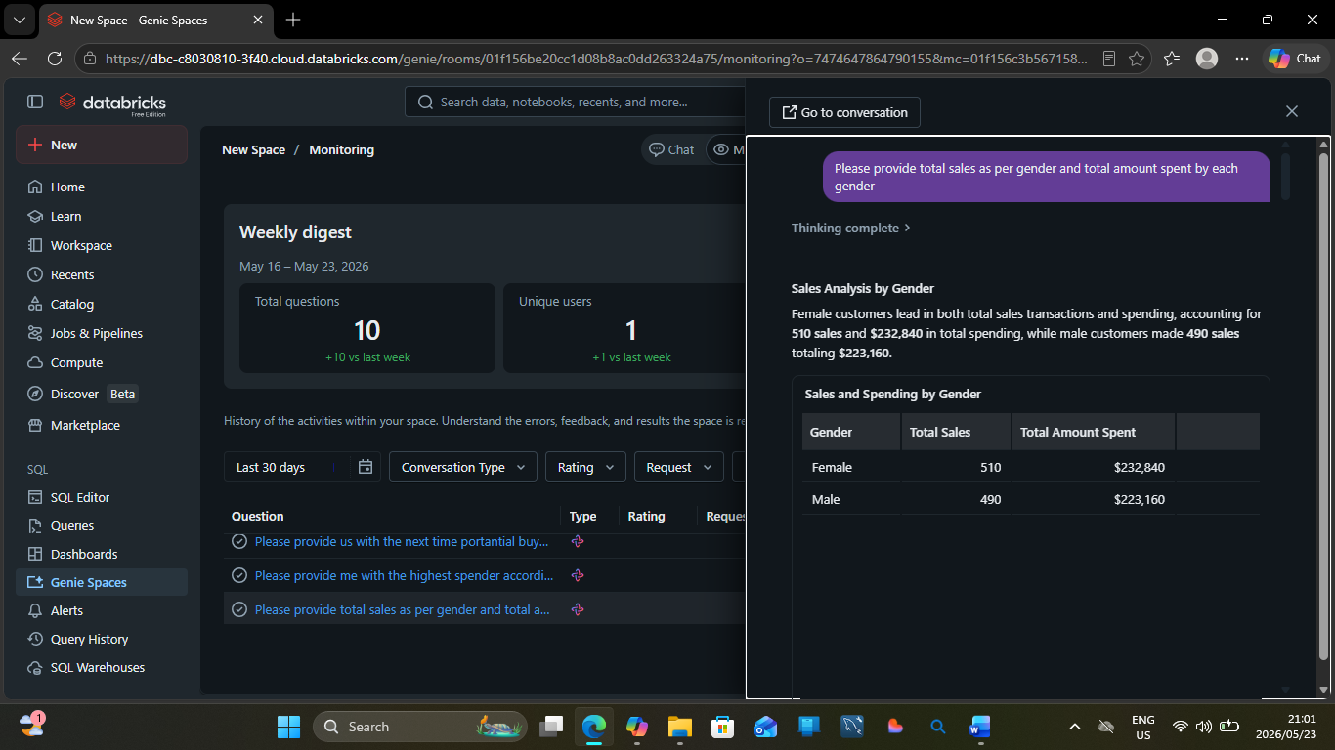
Q7 Test Screenshot


Q.8
Please provide us with the next time potential buyers and high spenders on our next table according to this table using customer id and categories
Thinking complete
A.8
Potential High-Value Buyers for Next Campaign
Based on historical spending patterns, I've identified 30 premium customers who are recent purchasers (within 90 days) and have spent $1,500+ in specific product categories, making them ideal targets for your next marketing campaign.
Key Insights
Customer Base Structure: All 1,000 customers in the dataset are one-time buyers with no repeat purchases, which presents both a challenge and an opportunity for retention-focused campaigns.
High-Value Segment: Among customers who spent $1,500 or more, there are 99 high-value customers across all three product categories (Beauty, Clothing, Electronics). The distribution shows 33 Premium customers (spending $2,000+) and 66 High-Value customers (spending $1,500-$1,999).
Recency Analysis: Of the high-value customers, 30 are recent buyers (purchased within the last 90 days), 23 are moderate (91-180 days), and 46 are dormant (180+ days). Recent buyers represent the highest-priority segment for immediate engagement.
Target Customer List
Customer ID | Preferred Category | Total Spent | Last Purchase | Days Since Purchase | Value Tier
CUST664 | Clothing | $2,000 | 2023-12-28 | 3 | Premium
CUST139 | Beauty | $2,000 | 2023-12-15 | 16 | Premium
CUST700 | Electronics | $2,000 | 2023-12-09 | 22 | Premium
CUST065 | Electronics | $2,000 | 2023-12-05 | 26 | Premium
CUST074 | Beauty | $2,000 | 2023-11-22 | 39 | Premium
CUST595 | Clothing | $2,000 | 2023-11-09 | 52 | Premium
CUST124 | Clothing | $2,000 | 2023-10-27 | 65 | Premium
CUST503 | Beauty | $2,000 | 2023-10-25 | 67 | Premium
CUST342 | Clothing | $2,000 | 2023-10-24 | 68 | Premium
CUST109 | Electronics | $2,000 | 2023-10-18 | 74 | Premium
CUST634 | Electronics | $2,000 | 2023-10-08 | 84 | Premium
CUST735 | Clothing | $2,000 | 2023-10-04 | 88 | Premium
CUST211 | Beauty | $1,500 | 2024-01-01 | -1 | High-Value
CUST805 | Beauty | $1,500 | 2023-12-29 | 2 | High-Value
CUST580 | Clothing | $1,500 | 2023-12-06 | 25 | High-Value
CUST199 | Beauty | $1,500 | 2023-12-04 | 27 | High-Value
CUST608 | Electronics | $1,500 | 2023-12-02 | 29 | High-Value
CUST112 | Clothing | $1,500 | 2023-12-02 | 29 | High-Value
CUST215 | Clothing | $1,500 | 2023-11-29 | 32 | High-Value
CUST115 | Clothing | $1,500 | 2023-11-26 | 35 | High-Value
CUST169 | Beauty | $1,500 | 2023-11-17 | 44 | High-Value
CUST533 | Electronics | $1,500 | 2023-11-16 | 45 | High-Value
CUST369 | Electronics | $1,500 | 2023-11-15 | 46 | High-Value
CUST047 | Beauty | $1,500 | 2023-11-06 | 55 | High-Value
CUST507 | Electronics | $1,500 | 2023-11-02 | 59 | High-Value
CUST710 | Electronics | $1,500 | 2023-10-31 | 61 | High-Value
CUST677 | Beauty | $1,500 | 2023-10-27 | 65 | High-Value
CUST869 | Beauty | $1,500 | 2023-10-25 | 67 | High-Value
CUST711 | Electronics | $1,500 | 2023-10-16 | 76 | High-Value
CUST385 | Electronics | $1,500 | 2023-10-06 | 86 | High-Value
The table above shows your top 30 potential buyers, prioritized by spending amount and recency. These customers have demonstrated high purchase value and recent engagement, making them prime candidates for:
- Category-specific promotions based on their preferred product category
- Re-engagement campaigns to convert them into repeat customers
- Premium loyalty programs to increase lifetime value
Distribution Insights

Dormant
Recent
Moderate
Electronics has the highest number of dormant premium customers (11), representing a significant re-engagement opportunity. Beauty and Clothing show more balanced distributions, with recent customers still actively engaged.

High-Value
Premium
Recommendations
- Immediate Action: Target the 12 Premium customers who purchased within the last 90 days with exclusive offers in their preferred categories
- Re-engagement Campaign: Focus on the 46 dormant high-value customers, particularly the 25 in Electronics and Clothing, with win-back incentives
- Retention Strategy: Since all customers are one-time buyers, implement a loyalty program to encourage repeat purchases and increase customer lifetime value

Is this useful?

now please give out a summary on the customer revenue according to the table, and also create a doughnut table describing this to the CEO on what to expect and how has the company done in the dates given on the table and what was the total revenue
Thinking complete
Executive Summary: Customer Revenue Performance
The company generated $456,000 in total revenue from 1,000 transactions across 1,000 unique customers during the period from January 1, 2023 to January 1, 2024, with an average transaction value of $456.
Key Performance Metrics
Metric | Value | % of Total
Total Revenue | $456,000 | 100%
Total Transactions | 1,000 | -
Unique Customers | 1,000 | -
Average Transaction Value | $456 | -
Period | Jan 1, 2023 - Jan 1, 2024 | -
Electronics Revenue | $156,905 | 34.4%
Clothing Revenue | $155,580 | 34.1%
Beauty Revenue | $143,515 | 31.5%
Female Customer Revenue | $232,840 | 51.1%
Male Customer Revenue | $223,160 | 48.9%
Revenue Distribution Insights
Product Category Performance: Revenue is well-balanced across all three product categories, with Electronics leading at $156,905 (34.4%), followed closely by Clothing at $155,580 (34.1%), and Beauty at $143,515 (31.5%). This balanced distribution indicates healthy diversification with no over-reliance on a single category.

Electronics
Clothing
Beauty
Gender Distribution: Female customers contributed $232,840 (51.1%) of total revenue across 510 transactions, while male customers generated $223,160 (48.9%) from 490 transactions. The revenue split is nearly equal, with both genders showing similar average transaction values around $456.

Female
Male
Monthly Performance Trends

Revenue Volatility: Monthly revenue showed significant fluctuation throughout 2023, ranging from a low of $23,620 in September to a peak of $53,150 in May. The strongest months were May ($53,150), February ($44,060), and December ($44,690), while the weakest were September ($23,620) and March ($28,990).
Customer Acquisition Pattern: Each transaction represents a unique customer (1,000 transactions = 1,000 customers), indicating this is primarily a customer acquisition dataset with no repeat purchases recorded. This presents a significant opportunity to implement retention strategies and loyalty programs to drive repeat business.
What to Expect Going Forward
- Revenue Stability: With balanced category performance and equal gender distribution, the business has a stable foundation without concentration risk
- Growth Opportunity: The absence of repeat customers represents a major untapped opportunity—converting even 20% of customers to make a second purchase could increase annual revenue by $91,200
- Seasonal Patterns: May and December showed strong performance, suggesting potential seasonal trends that could be leveraged for targeted campaigns
- Average Order Value: At $456 per transaction, there's room to increase basket size through cross-selling and upselling strategies, particularly in the high-value customer segments identified earlier

Q.8 Screenshot
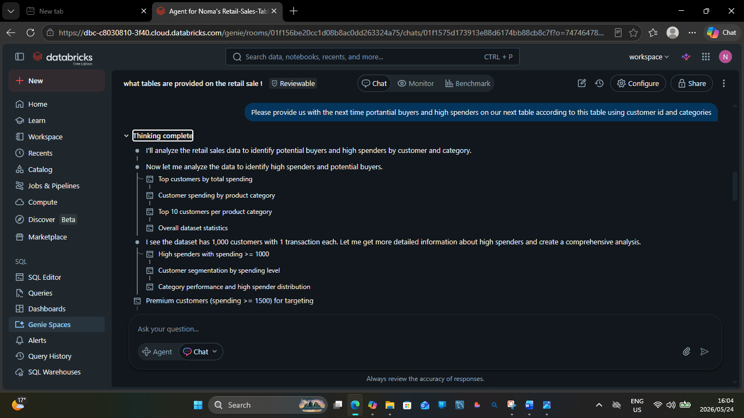

Q.8 Test Screenshot
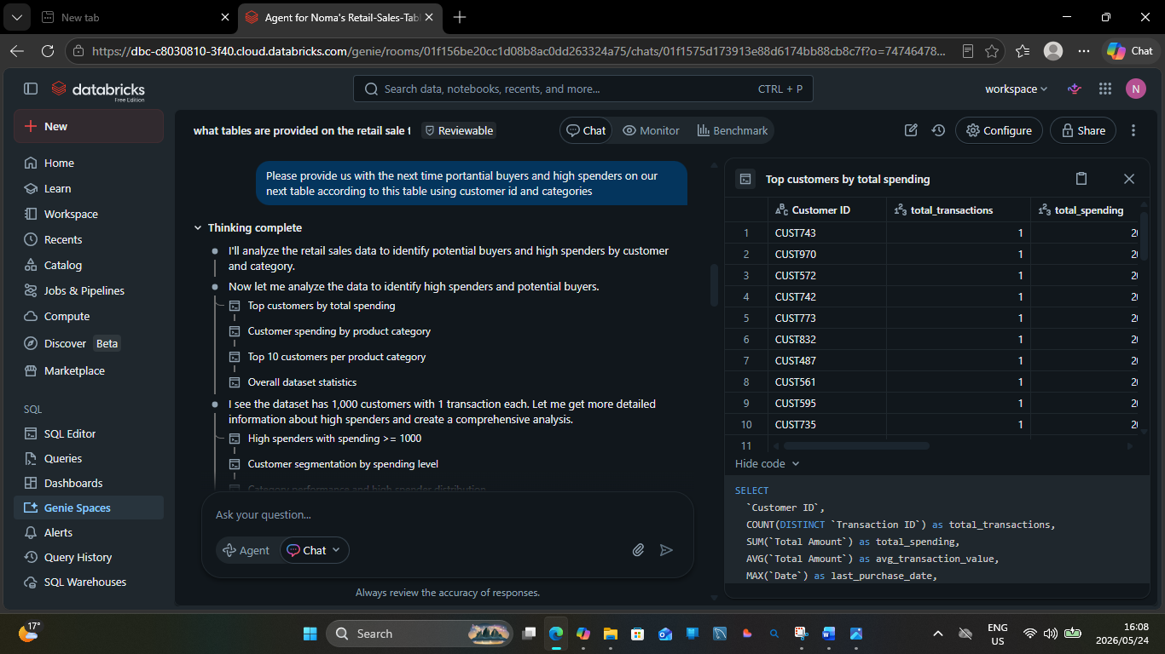

Q.9

Please provide us with the next time potential buyers and high spenders on our next table according to this table using customer id and categories
Thinking complete
A.9
Potential High-Value Buyers for Next Campaign
Based on historical spending patterns, I've identified 30 premium customers who are recent purchasers (within 90 days) and have spent $1,500+ in specific product categories, making them ideal targets for your next marketing campaign.
Key Insights
Customer Base Structure: All 1,000 customers in the dataset are one-time buyers with no repeat purchases, which presents both a challenge and an opportunity for retention-focused campaigns.
High-Value Segment: Among customers who spent $1,500 or more, there are 99 high-value customers across all three product categories (Beauty, Clothing, Electronics). The distribution shows 33 Premium customers (spending $2,000+) and 66 High-Value customers (spending $1,500-$1,999).
Recency Analysis: Of the high-value customers, 30 are recent buyers (purchased within the last 90 days), 23 are moderate (91-180 days), and 46 are dormant (180+ days). Recent buyers represent the highest-priority segment for immediate engagement.
Target Customer List
Customer ID | Preferred Category | Total Spent | Last Purchase | Days Since Purchase | Value Tier
CUST664 | Clothing | $2,000 | 2023-12-28 | 3 | Premium
CUST139 | Beauty | $2,000 | 2023-12-15 | 16 | Premium
CUST700 | Electronics | $2,000 | 2023-12-09 | 22 | Premium
CUST065 | Electronics | $2,000 | 2023-12-05 | 26 | Premium
CUST074 | Beauty | $2,000 | 2023-11-22 | 39 | Premium
CUST595 | Clothing | $2,000 | 2023-11-09 | 52 | Premium
CUST124 | Clothing | $2,000 | 2023-10-27 | 65 | Premium
CUST503 | Beauty | $2,000 | 2023-10-25 | 67 | Premium
CUST342 | Clothing | $2,000 | 2023-10-24 | 68 | Premium
CUST109 | Electronics | $2,000 | 2023-10-18 | 74 | Premium
CUST634 | Electronics | $2,000 | 2023-10-08 | 84 | Premium
CUST735 | Clothing | $2,000 | 2023-10-04 | 88 | Premium
CUST211 | Beauty | $1,500 | 2024-01-01 | -1 | High-Value
CUST805 | Beauty | $1,500 | 2023-12-29 | 2 | High-Value
CUST580 | Clothing | $1,500 | 2023-12-06 | 25 | High-Value
CUST199 | Beauty | $1,500 | 2023-12-04 | 27 | High-Value
CUST608 | Electronics | $1,500 | 2023-12-02 | 29 | High-Value
CUST112 | Clothing | $1,500 | 2023-12-02 | 29 | High-Value
CUST215 | Clothing | $1,500 | 2023-11-29 | 32 | High-Value
CUST115 | Clothing | $1,500 | 2023-11-26 | 35 | High-Value
CUST169 | Beauty | $1,500 | 2023-11-17 | 44 | High-Value
CUST533 | Electronics | $1,500 | 2023-11-16 | 45 | High-Value
CUST369 | Electronics | $1,500 | 2023-11-15 | 46 | High-Value
CUST047 | Beauty | $1,500 | 2023-11-06 | 55 | High-Value
CUST507 | Electronics | $1,500 | 2023-11-02 | 59 | High-Value
CUST710 | Electronics | $1,500 | 2023-10-31 | 61 | High-Value
CUST677 | Beauty | $1,500 | 2023-10-27 | 65 | High-Value
CUST869 | Beauty | $1,500 | 2023-10-25 | 67 | High-Value
CUST711 | Electronics | $1,500 | 2023-10-16 | 76 | High-Value
CUST385 | Electronics | $1,500 | 2023-10-06 | 86 | High-Value
The table above shows your top 30 potential buyers, prioritized by spending amount and recency. These customers have demonstrated high purchase value and recent engagement, making them prime candidates for:
- Category-specific promotions based on their preferred product category
- Re-engagement campaigns to convert them into repeat customers
- Premium loyalty programs to increase lifetime value
Distribution Insights

Dormant
Recent
Moderate
Electronics has the highest number of dormant premium customers (11), representing a significant re-engagement opportunity. Beauty and Clothing show more balanced distributions, with recent customers still actively engaged.

High-Value
Premium
Recommendations
- Immediate Action: Target the 12 Premium customers who purchased within the last 90 days with exclusive offers in their preferred categories
- Re-engagement Campaign: Focus on the 46 dormant high-value customers, particularly the 25 in Electronics and Clothing, with win-back incentives
- Retention Strategy: Since all customers are one-time buyers, implement a loyalty program to encourage repeat purchases and increase customer lifetime value

Is this useful?

now please give out a summary on the customer revenue according to the table, and also create a doughnut table describing this to the CEO on what to expect and how has the company done in the dates given on the table and what was the total revenue
Thinking complete
Executive Summary: Customer Revenue Performance
The company generated $456,000 in total revenue from 1,000 transactions across 1,000 unique customers during the period from January 1, 2023 to January 1, 2024, with an average transaction value of $456.
Key Performance Metrics
Metric | Value | % of Total
Total Revenue | $456,000 | 100%
Total Transactions | 1,000 | -
Unique Customers | 1,000 | -
Average Transaction Value | $456 | -
Period | Jan 1, 2023 - Jan 1, 2024 | -
Electronics Revenue | $156,905 | 34.4%
Clothing Revenue | $155,580 | 34.1%
Beauty Revenue | $143,515 | 31.5%
Female Customer Revenue | $232,840 | 51.1%
Male Customer Revenue | $223,160 | 48.9%
Revenue Distribution Insights
Product Category Performance: Revenue is well-balanced across all three product categories, with Electronics leading at $156,905 (34.4%), followed closely by Clothing at $155,580 (34.1%), and Beauty at $143,515 (31.5%). This balanced distribution indicates healthy diversification with no over-reliance on a single category.

Electronics
Clothing
Beauty
Gender Distribution: Female customers contributed $232,840 (51.1%) of total revenue across 510 transactions, while male customers generated $223,160 (48.9%) from 490 transactions. The revenue split is nearly equal, with both genders showing similar average transaction values around $456.

Female
Male
Monthly Performance Trends

Revenue Volatility: Monthly revenue showed significant fluctuation throughout 2023, ranging from a low of $23,620 in September to a peak of $53,150 in May. The strongest months were May ($53,150), February ($44,060), and December ($44,690), while the weakest were September ($23,620) and March ($28,990).
Customer Acquisition Pattern: Each transaction represents a unique customer (1,000 transactions = 1,000 customers), indicating this is primarily a customer acquisition dataset with no repeat purchases recorded. This presents a significant opportunity to implement retention strategies and loyalty programs to drive repeat business.
What to Expect Going Forward
- Revenue Stability: With balanced category performance and equal gender distribution, the business has a stable foundation without concentration risk
- Growth Opportunity: The absence of repeat customers represents a major untapped opportunity—converting even 20% of customers to make a second purchase could increase annual revenue by $91,200
- Seasonal Patterns: May and December showed strong performance, suggesting potential seasonal trends that could be leveraged for targeted campaigns
- Average Order Value: At $456 per transaction, there's room to increase basket size through cross-selling and upselling strategies, particularly in the high-value customer segments identified earlier

Q.9 Screenshot
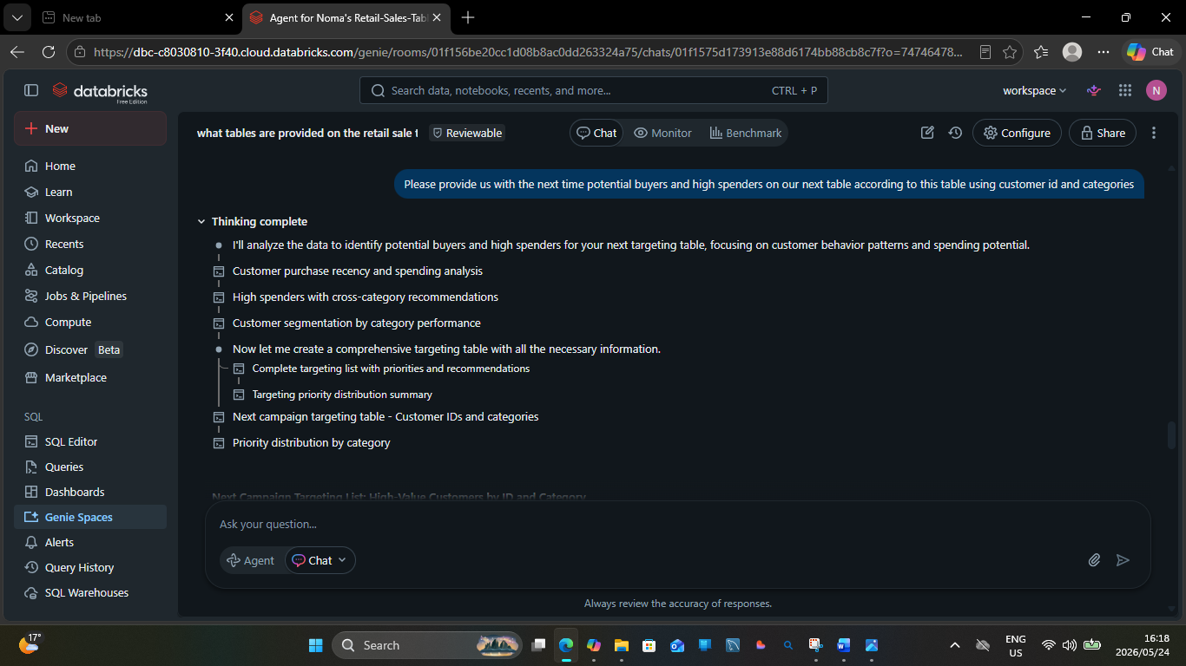
Q.9 Test Screenshot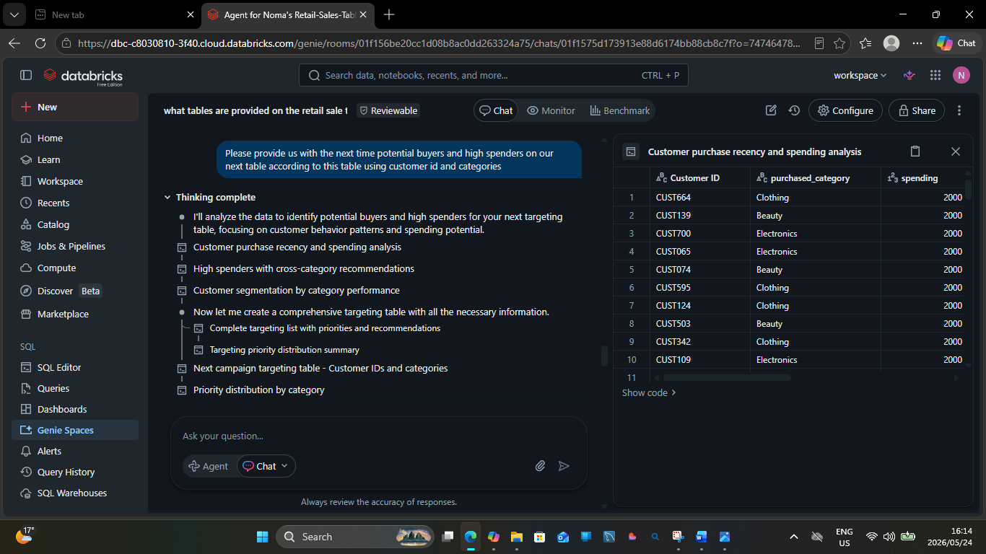

Q.10
Q.10
now please give out a summary on the customer revenue according to the table, and also create a doughnut table describing this to the CEO on what to expect and how has the company done in the dates given on the table and what was the total revenue
Thinking complete
A.10
Executive Summary: Customer Revenue Performance
The company generated $456,000 in total revenue from 1,000 transactions across 1,000 unique customers during the period from January 1, 2023 to January 1, 2024, with an average transaction value of $456.
Key Performance Metrics
Metric | Value | % of Total
Total Revenue | $456,000 | 100%
Total Transactions | 1,000 | -
Unique Customers | 1,000 | -
Average Transaction Value | $456 | -
Period | Jan 1, 2023 - Jan 1, 2024 | -
Electronics Revenue | $156,905 | 34.4%
Clothing Revenue | $155,580 | 34.1%
Beauty Revenue | $143,515 | 31.5%
Female Customer Revenue | $232,840 | 51.1%
Male Customer Revenue | $223,160 | 48.9%
Revenue Distribution Insights
Product Category Performance: Revenue is well-balanced across all three product categories, with Electronics leading at $156,905 (34.4%), followed closely by Clothing at $155,580 (34.1%), and Beauty at $143,515 (31.5%). This balanced distribution indicates healthy diversification with no over-reliance on a single category.

Electronics
Clothing
Beauty
Gender Distribution: Female customers contributed $232,840 (51.1%) of total revenue across 510 transactions, while male customers generated $223,160 (48.9%) from 490 transactions. The revenue split is nearly equal, with both genders showing similar average transaction values around $456.

Female
Male
Monthly Performance Trends

Revenue Volatility: Monthly revenue showed significant fluctuation throughout 2023, ranging from a low of $23,620 in September to a peak of $53,150 in May. The strongest months were May ($53,150), February ($44,060), and December ($44,690), while the weakest were September ($23,620) and March ($28,990).
Customer Acquisition Pattern: Each transaction represents a unique customer (1,000 transactions = 1,000 customers), indicating this is primarily a customer acquisition dataset with no repeat purchases recorded. This presents a significant opportunity to implement retention strategies and loyalty programs to drive repeat business.
What to Expect Going Forward
- Revenue Stability: With balanced category performance and equal gender distribution, the business has a stable foundation without concentration risk
- Growth Opportunity: The absence of repeat customers represents a major untapped opportunity—converting even 20% of customers to make a second purchase could increase annual revenue by $91,200
- Seasonal Patterns: May and December showed strong performance, suggesting potential seasonal trends that could be leveraged for targeted campaigns
- Average Order Value: At $456 per transaction, there's room to increase basket size through cross-selling and upselling strategies, particularly in the high-value customer segments identified earlier
Q.10 Screenshot
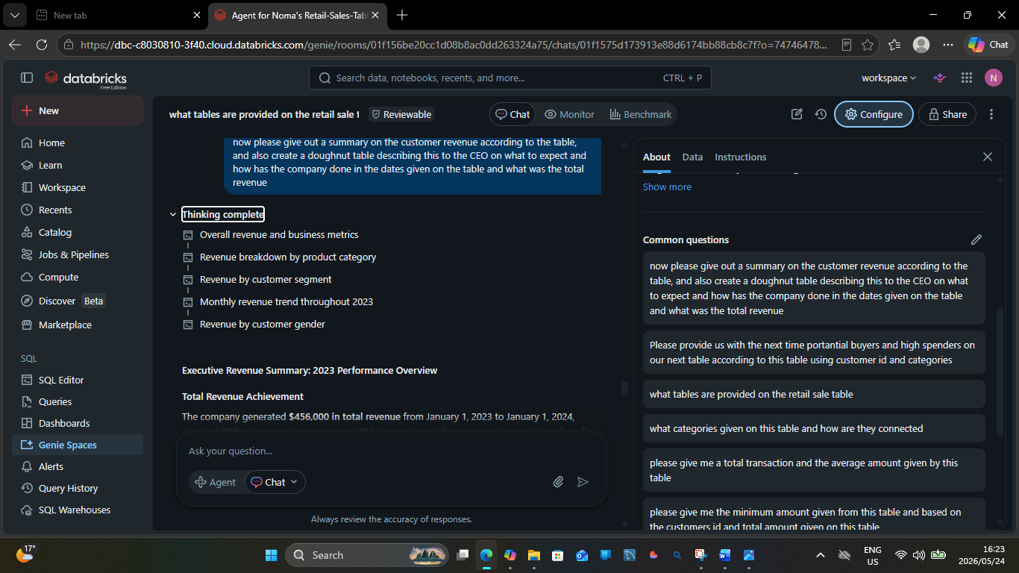
Q.10 Test Screenshot
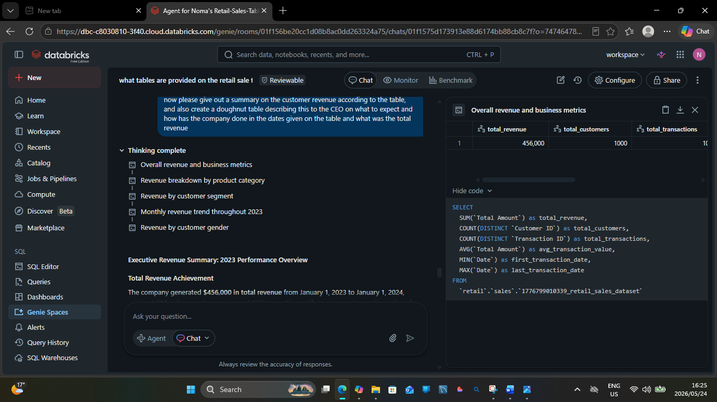

Validation of 3 Answers
1. Q.7
Q.7
Please provide total sales as per gender and total amount spent by each gender
Thinking complete
A.7
Sales Analysis by Gender
Female customers lead in both total sales transactions and spending, accounting for 510 sales and $232,840 in total spending, while male customers made 490 sales totaling $223,160.

Tested Answer Q.7
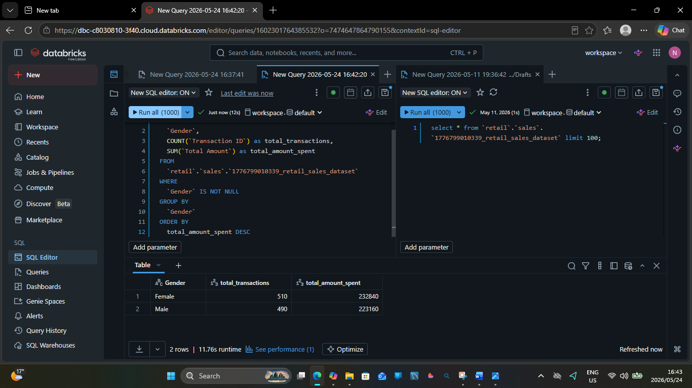

Q.
Q.4
please give me the minimum amount given from this table and based on the customers id and total amount given on this table
Thinking complete
Minimum Transaction Amount
A.4The minimum transaction amount in the table is $25, which appears in 51 different transactions across various customers and product categories.
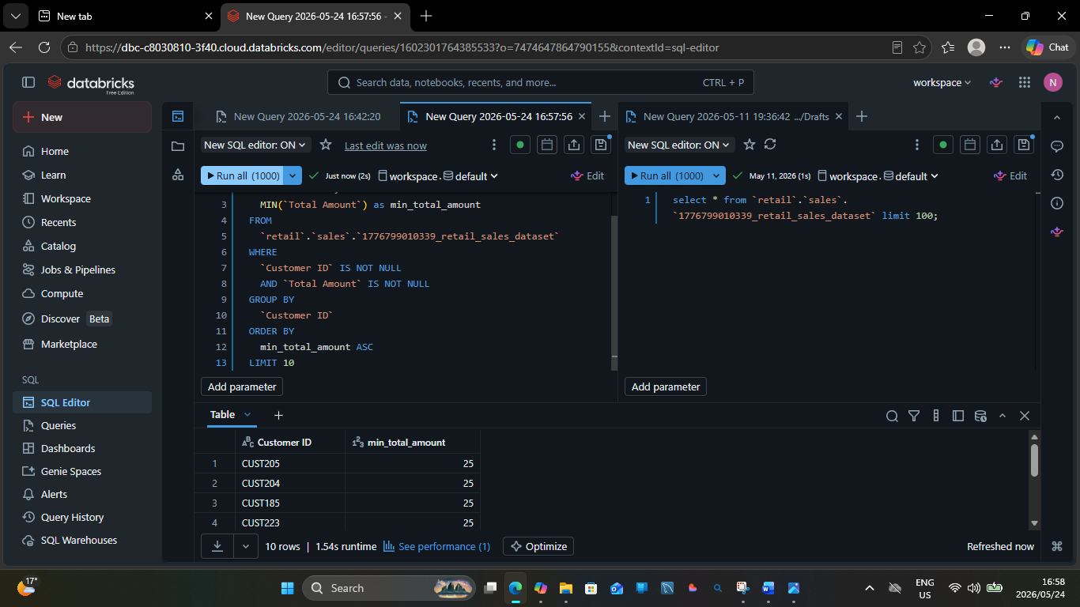

3.
Q.5
please give me the maximum amount given from this table and based on the customers id and total amount given on this table
Thinking complete
A.5
- Maximum transaction amount details
- Customers with highest total spending
- Maximum transaction amount details simplified
Validated Answer
